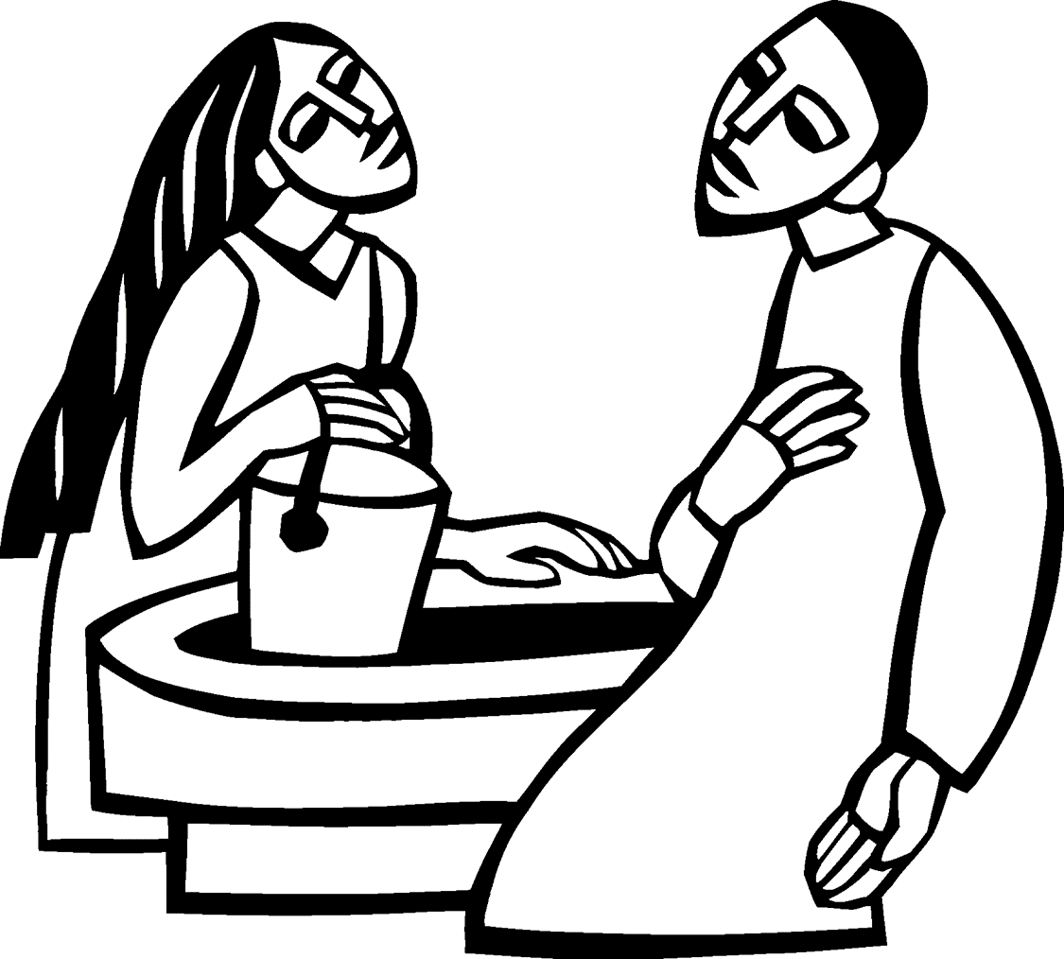

The Eve of Lent 3

March 14, 2020

**GRACE LUTHERAN CHURCH**

*Making Christ Known to all Through Grace*

2225 Washington Street, Lincoln NE 68502 + 402-474-1505 + [www.egrace.org](http://www.egrace.org)

**WELCOME to worship**

Grace Lutheran Church, a church of the Evangelical Lutheran Church in America, has been at the heart of the faith community in Lincoln since 1889.

* We are deeply committed to our mission: "Making Christ known to all through Grace."
* We celebrate our purpose: "That by God's grace we have been gathered to worship, called to witness, and sent to serve."
* We are excited about our vision: "To become a church with a passion for fostering a welcoming community that strives for peace and a sense of belonging."

Thank you for worshipping with us today and join our community at any time!

**INTRODUCTION to worship**

During Lent we journey with all those around the world who will be baptized at the Easter Vigil. In today’s gospel Jesus tells Nicodemus that he must be born of water and Spirit. At the font we are a given a new birth as children of God. As God made a covenant with Abraham, in baptism God promises to raise us up with Christ to new life. From worship we are sent forth to proclaim God’s love for all the world.

**_________________________________________________________________________________________**

**GATHERING**

The Holy Spirit calls us together as the people of God.

**PRELUDE**

**WELCOMe and announcements**

**Confession and Forgiveness**

Blessed be the holy Trinity, ☩ one God, who is present, who gives life, who calls into existence the things that do not exist. **Amen.**

If you were to keep watch over sins, O Lord, who could stand? Yet with you is forgiveness, and so we confess. *Silence is kept for reflection.*

Gracious God,

**have mercy on us. We confess that we have turned away from you, knowingly and unknowingly. We have wandered from your resurrection life. We have strayed from your love for all people. Turn us back to you, O God. Give us new hearts and right spirits, that we may find what is pleasing to you and dwell in your house forever. Amen.**

Receive good news: God turns to you in love. “I will put my spirit in you, and you shall live,” says our God. All your sin is forgiven in the name of ☩ Jesus Christ, who is the free and abounding gift of God’s grace for you. **Amen.**

**GATHERING HYMN** ELW 325

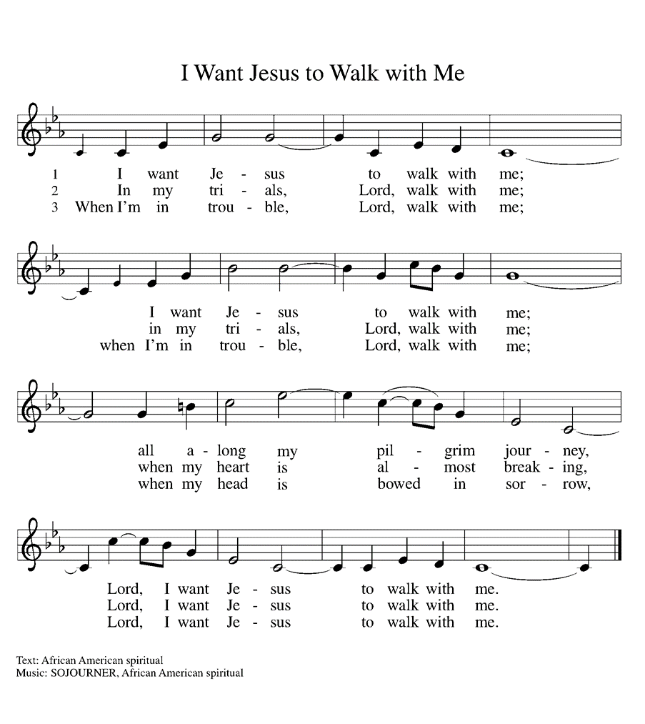

**GREETING**

The grace of our Lord Jesus Christ, the love of God, and the communion of the Holy Spirit be with you. **And, also with you.**

**PRAYER OF THE DAY**

Merciful God, the fountain of living water, you quench our thirst and wash away our sin. Give us this water always. Bring us to drink from the well that flows with the beauty of your truth through Jesus Christ, our Savior and Lord, who lives and reigns with you and the Holy Spirit, one God, now and forever. **Amen.**

**__________________________________________________________________________________________**

**WORD**

God speaks to us in scripture, preaching and song.

*Sit*

First Reading: Exodus 17:1-7

*Because the thirsty Israelites quarreled with Moses and put God to the test, Moses cried out in desperation to God. God commanded Moses to strike the rock to provide water for the people. The doubt-filled question—“Is the Lord among us or not?”—received a very positive answer.*

1From the wilderness of Sin the whole congregation of the Israelites journeyed by stages, as the Lord commanded. They camped at Rephidim, but there was no water for the people to drink. 2The people quarreled with Moses, and said, “Give us water to drink.” Moses said to them, “Why do you quarrel with me? Why do you test the Lord?” 3But the people thirsted there for water; and the people complained against Moses and said, “Why did you bring us out of Egypt, to kill us and our children and livestock with thirst?” 4So Moses cried out to the Lord, “What shall I do with this people? They are almost ready to stone me.” 5The Lord said to Moses, “Go on ahead of the people, and take some of the elders of Israel with you; take in your hand the staff with which you struck the Nile, and go. 6I will be standing there in front of you on the rock at Horeb. Strike the rock, and water will come out of it, so that the people may drink.” Moses did so, in the sight of the elders of Israel. 7He called the place Massah and Meribah, because the Israelites quarreled and tested the Lord, saying, “Is the Lord among us or not?”

The Word of the Lord. **Thanks be to God.**

Psalm: Psalm 95

1Come, let us sing to the Lord;  
  let us shout for joy to the rock of our salvation.  
 2**Let us come before God’s presence with thanksgiving**  
  **and raise a loud shout to the Lord with psalms.**  
 3For you, Lord, are a great God,  
  and a great ruler above all gods.  
 4**In your hand are the caverns of the earth;**  
  **the heights of the hills are also yours.**  
 5The sea is yours, for you made it,  
  and your hands have molded the dry land.  
 6**Come, let us worship and bow down,**  
  **let us kneel before the Lord our maker.**

Second Reading: Romans 5:1-5

*Though we often hear that God helps those who help themselves, here Paul tells us that through Jesus’ death God helps utterly helpless sinners. Since we who had been enemies are reconciled to God in the cross, we now live in hope for our final salvation.*

1Since we are justified by faith, we have peace with God through our Lord Jesus Christ, 2through whom we have obtained access to this grace in which we stand; and we boast in our hope of sharing the glory of God. 3And not only that, but we also boast in our sufferings, knowing that suffering produces endurance, 4and endurance produces character, and character produces hope, 5and hope does not disappoint us, because God’s love has been poured into our hearts through the Holy Spirit that has been given to us.

The Word of the Lord. **Thanks be to God.**

*Stand*

The Holy Gospel according John. **Glory to you, O Lord.**

Gospel: John 4:5-15

*Jesus defies convention to engage a Samaritan woman in conversation. Her testimony, in turn, leads many others to faith.*

5[Jesus] came to a Samaritan city called Sychar, near the plot of ground that Jacob had given to his son Joseph.6Jacob’s well was there, and Jesus, tired out by his journey, was sitting by the well. It was about noon.  
  7A Samaritan woman came to draw water, and Jesus said to her, “Give me a drink.” 8(His disciples had gone to the city to buy food.) 9The Samaritan woman said to him, “How is it that you, a Jew, ask a drink of me, a woman of Samaria?” (Jews do not share things in common with Samaritans.) 10Jesus answered her, “If you knew the gift of God, and who it is that is saying to you, ‘Give me a drink,’ you would have asked him, and he would have given you living water.” 11The woman said to him, “Sir, you have no bucket, and the well is deep. Where do you get that living water? 12Are you greater than our ancestor Jacob, who gave us the well, and with his sons and his flocks drank from it?” 13Jesus said to her, “Everyone who drinks of this water will be thirsty again, 14but those who drink of the water that I will give them will never be thirsty. The water that I will give will become in them a spring of water gushing up to eternal life.” 15The woman said to him, “Sir, give me this water, so that I may never be thirsty or have to keep coming here to draw water.”

The Gospel of the Lord. **Praise to you, O Christ.**

*Sit*

**SERMON**

*stand*

**HYMN OF THE DAY**

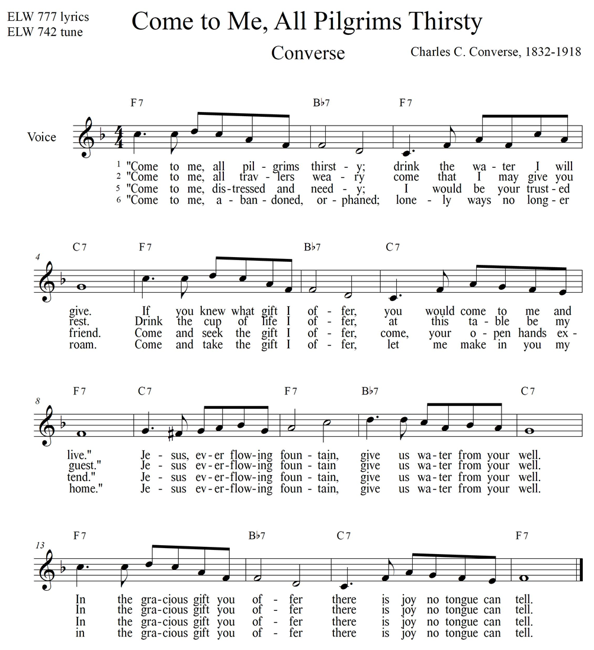

**APOSTLE’S CREED**

**I believe in God, the Father almighty,**

**creator of heaven and earth.**

**I believe in Jesus Christ, God’s only Son, our Lord,**

**who was conceived by the Holy Spirit,**

**born of the virgin Mary,**

**suffered under Pontius Pilate,**

**was crucified, died, and was buried;**

**he descended to the dead.**

**On the third day he rose again;**

**he ascended into heaven,**

**he is seated at the right hand of the Father,**

**and he will come to judge the living and the dead.**

**I believe in the Holy Spirit,**

**the holy catholic church,**

**the communion of saints,**

**the forgiveness of sins,**

**the resurrection of the body,**

**and the life everlasting. Amen.**

**Prayers of Intercession**

Turning our hearts to God who is gracious and merciful, we pray for the church, the world, and all who are in need. *A brief silence.*

God of living water, send your church beyond boundaries to proclaim your grace. May its witness be a source of refreshment for thirsty souls. Strengthen our voices, that all people can know and believe that Jesus is truly the savior of the world. Hear us, O God. **Your mercy is great.**

God of living water, protect from pollution or misuse all rivers, lakes, oceans, and streams. Bless the work of those who dig wells and those who advocate for access to clean water, that all people and animals have enough to drink. Hear us, O God. **Your mercy is great.**

God of living water, open the hearts of leaders and authorities, that they hear the cries of the suffering and act with compassion toward them. Bring peace to disputed lands and bring reconciliation to people divided by race, culture, or nationality. Hear us, O God. **Your mercy is great.**

God of living water, mend the hearts of those who grieve broken relationships, whether by conflict, abuse, divorce, or death. Draw near to all who are ill. Assure those questioning your presence during doubt or suffering, especially those we name before you silently or aloud…Hear us, O God. **Your mercy is great.**

God of living water, renew us in the promises of baptism. Join us together in worship, fellowship, and sharing your good news. Embolden us to serve others and to work for justice and peace. Hear us, O God. **Your mercy is great.**

God of living water, we thank you for those who endured suffering and who now boast in the glory of God. Pour your Holy Spirit into our hearts and give us peace as we live in the hope of our salvation. Hear us, O God. **Your mercy is great.**

According to your steadfast love, O God, hear these and all our prayers as we commend them to you; through Christ our Lord. **Amen.**

**__________________________________________________________________________________________**

**MEAL**

*God feeds us with the presence of Jesus Christ.*

*sit*

**OFFERING**

*Stand*

**OFFERING PRAYER**

Holy and generous host, you set a table where we feast as friends. Prepare us to witness to your goodness

with every gift you have given us to share, that all people may know your peace through Jesus Christ, now and forever. **Amen.**

**DIALOG**

The Lord be with you.

**And also, with you.**

Lift up your hearts.

**We lift them to the Lord.**

Let us give thanks to the Lord our God.

**It is right to give our thanks and praise.**

**THANKSGIVING AT THE TABLE**

Holy God, our living Water and our merciful Guide, together with rivers and seas, wells and springs we bless and magnify you. You led your people Israel through the desert, and provided them water from the rock.

We praise you for Christ, our Rock and our Water, who joined us in our desert, pouring out his life for the world.

In the night in which he was betrayed,

our Lord Jesus took bread, and gave thanks;

broke it, and gave it to his disciples, saying:

Take and eat; this is my body, given for you.

Do this for the remembrance of me.

Again, after supper, he took the cup, gave thanks,

and gave it for all to drink, saying:

This cup is the new covenant in my blood,

shed for you and for all people for the forgiveness of sin.

Do this for the remembrance of me.

Remembering, therefore, his life, death, and resurrection, we await your salvation for all this thirsty world.

Pour out your Spirit on this holy food and on all the baptized gathered for this feast: wash away our sin, that we may be revived for our journey by the love of Christ.

Through him all glory and honor is yours, Almighty Father, with the Holy Spirit, in your holy Church, both now and forever. **Amen**

**Lord's Prayer**

**Our Father in heaven, hallowed be your name, your kingdom come, your will be done, on earth as in heaven. Give us today our daily bread. Forgive us our sins as we forgive those who sin against us. Save us from the time of trial and deliver us from evil. For the kingdom, the power, and the glory are yours, now and forever. Amen.**

**Invitation to Communion**

God’s love is poured out in Christ for you. Open yourselves to receive it.

*Sit*

**Communion**

*The elements will be distributed using intinction. After receiving the wafer, you may dip it into the wine.  If you want a gluten free wafer let your server know. If you do not want, the wine then do not dip the wafer but instead hold it above the cup.*

*Stand*

**Prayer after Communion**

We thank you, living God, for the body and blood of your Son, which sustains us in the wilderness and the garden alike. As Christ has loved us in this feast, so send us to love Christ in our neighbors. In Jesus’ name we pray. **Amen.**

**__________________________________________________________________________________________**

**SENDING**

*God sends us in mission to the world.*

**Blessing**

Now is the acceptable time. Now is the day of salvation. Holy God, speaking, spoken, and inspiring, ☩ bless you, unbind you, and send you in love and in peace. **Amen.**

**Sending HYMn** ELW 611

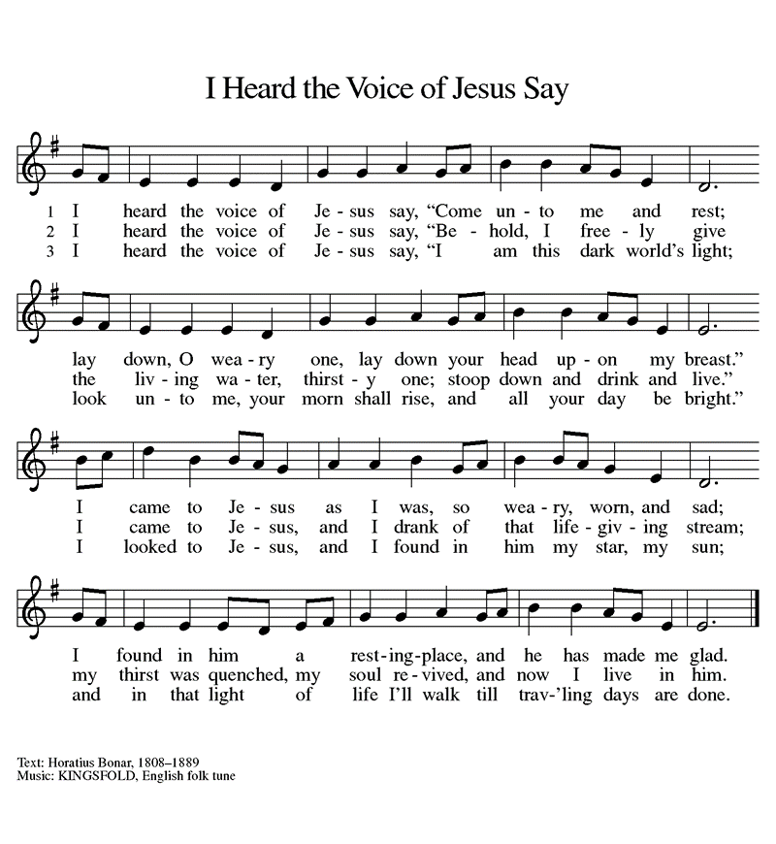

**Dismissal**

Go in peace. Share the good news. **Thanks be to God.**

**POSTLUDE**

*From Sundays and Seasons.com. Copyright 2020 Augsburg Fortress. All rights reserved. Reprinted by permission under Augsburg License #32714.*

WORSHIP LEADERS

Worship leader: Rev. Eric Lesher

Organist/Pianist: Ms. Anne Melang-Thoren/Jennifer Aliwarga-Carlson

Usher: Mr. Larry Watchhorn